**Robbito.com Text Updation**

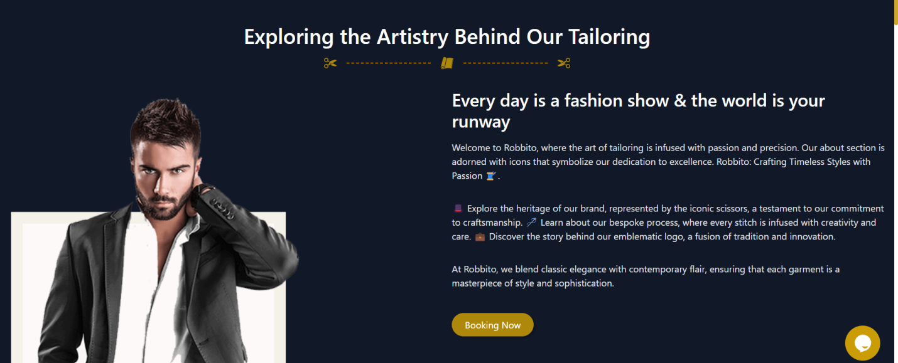

Heading : Introduction

We are taking dress making orders from around the world. Regardless of the ethnicity of fashion our professionals are equipped to create exactly as per your directions. At Robbito everything is done in-house. All required dress making departments under one roof at our purpose built factory powered by environmentally friendly renewable energy. We cater to all three segments of dress making demands, that is; you can either send us a picture of your reference article and we create it exactly like that or you have conceptualised the dress in your mind and you explain it to us to bring that dress to life, we guarantee to delight you with the outcome or you can ask one of ours highly creative designers to create a dress from scratch according to your dress niche.

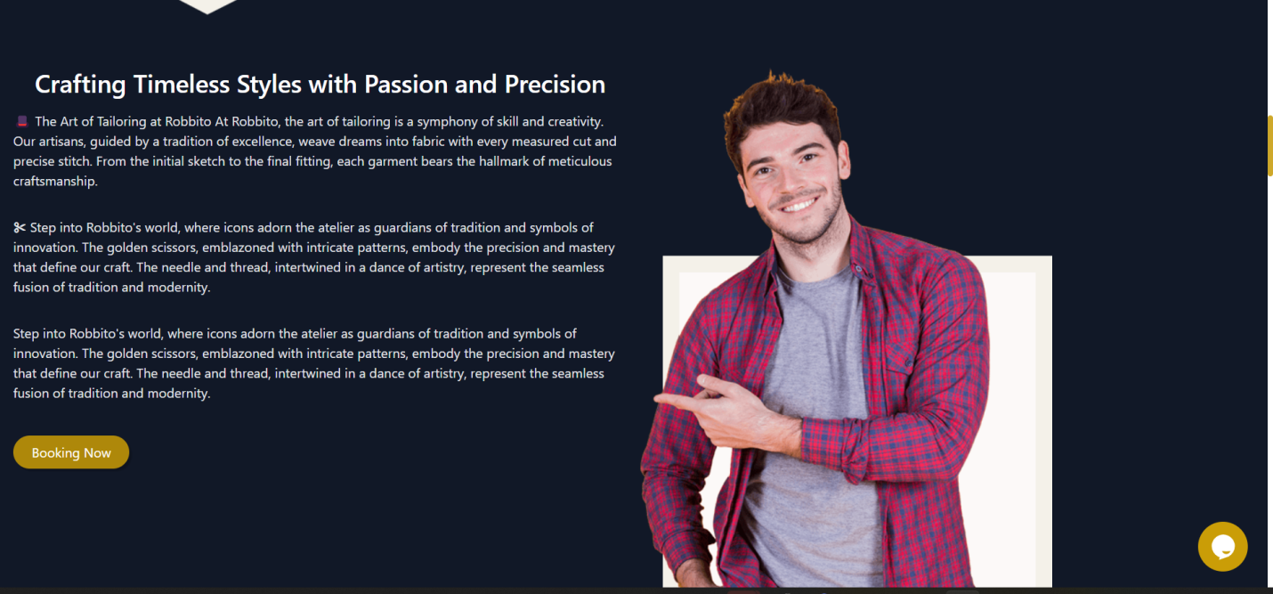

Remove this section:

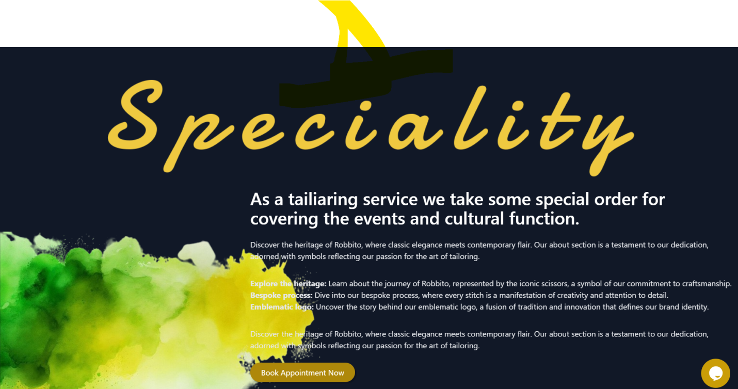

Remove heading speciality and write there: **Our Claim to Fame**

Change text to:

We make your dream dress in an unbelievable budget

That’s what makes us stand out from other market participants and that’s what’s our unique selling point. It’s not just quality delivered within a sharp deadline but we also ensure the most competitive price quotes. It always feels better when your favourite dress has been easy on the pocket as well.

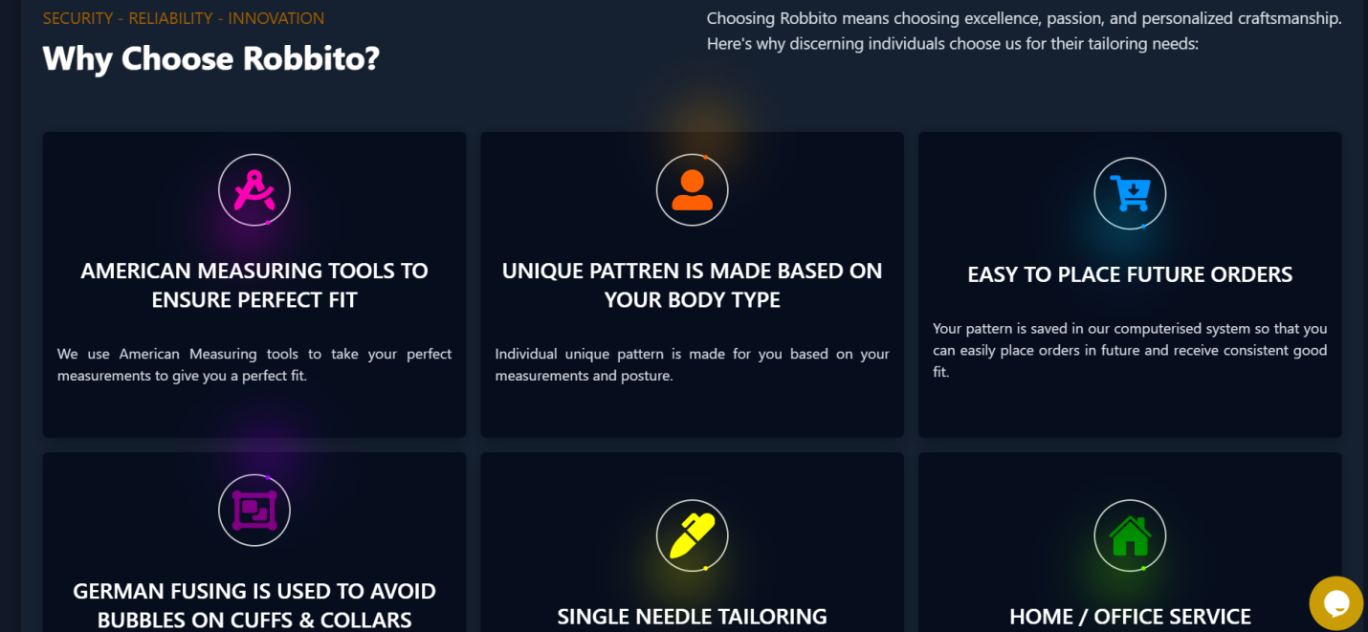

Change these points and icons according to this

**Easy payments checkout utility**

With our convenient payment gateway checkout you can pay through your credit/debit card from anywhere in the world all through a safe and seamless process

**Robbito is a product of BJ Textiles (Pvt) Limited. (add link on this box – bjtextiles.com**

Customised stitching division of BJ Textiles (Pvt) Limited. We felt that there is a vast vacuum in the market where the client should be facilitated to directly get their dress made from a Textile manufacturer

**User friendly process**

Robbito values ease of interacting for our clients. Our clients can initiate an order just by clicking on our WhatsApp link and get connected instantly to our agent.

**In-house couture worshop:**

Not only do we have all dress manufacturing departments under one roof including cutting, stitching, printing, dyeing and embroidery but we also have an in-house couture workshop where our highly skilled couture work and block print artists work round the clock in shifts to create your masterpieces.

**In-house fabric inventory**

Our manufacturing facility houses a vast variety of fabrics so that work starts on your dress the moment the order is finalised.

**Accessories Library**

Accessories garnish the dress. We have an elaborate accessories library for our designers to utilise while working on your dress.



Replace the text under logo

Bespoke Tailoring done to perfection by offering in depth craftsmanship.

And use Modern social media icons

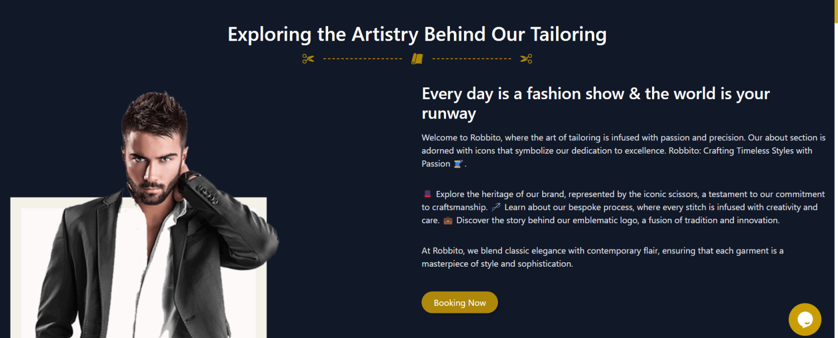

Change image there use this intro image

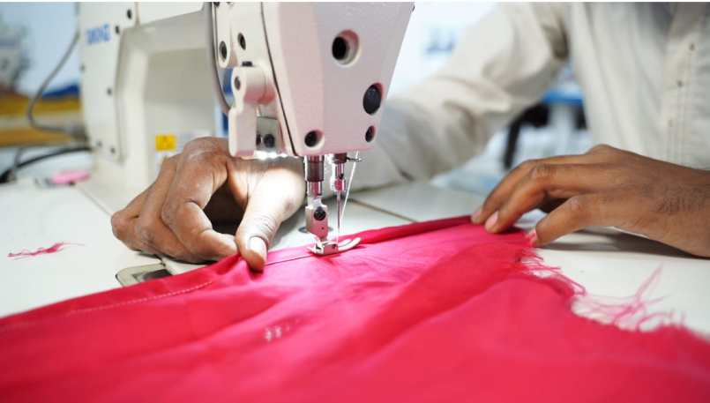

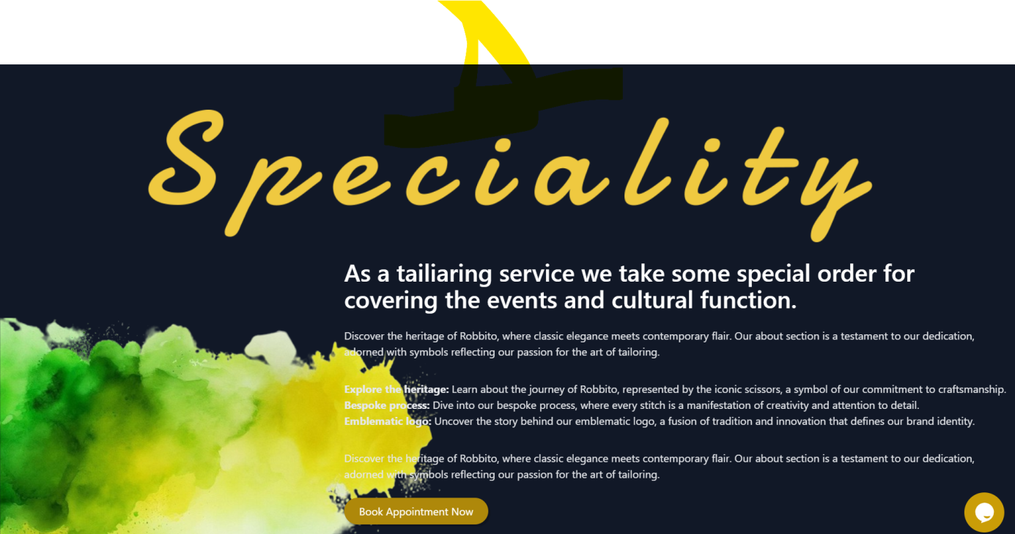

Add this Image on left side on this section couture pic

